**Lets Upgrade - Data Structures And Algorithms**

**Pratyusha Chakravarty**

**Assignment 2**

Question 1)

Write the program for deleting an element from the beginning and from any position.

Ans:

#include<stdio.h>

int main()

{

printf("Lets Upgrade - Data Structures and Algorithms");

int array[50], pos, num1, num2;

printf("\nEnter number of elements in array:");

scanf("%d", &num1);

printf("\nEnter %d elements", num1);

for(num2 = 0; num2 < num1; num2++)

scanf("%d", &array[num2]);

printf("\nEnter the location where you want to delete element from: ");

scanf("%d", &pos);

if(pos >= num1+1)

printf("\nDeletion not possible");

else

for(num2 = pos-1; num2 < num1-1; num2++)

array[num2] = array[num2+1];

printf("\nResultant array is: ");

/*

the array size gets reduced by 1

after deletion of the element

*/

for(num2 = 0; num2 < num1-1; num2++)

printf("%d ", array[num2]);

return 0;

}

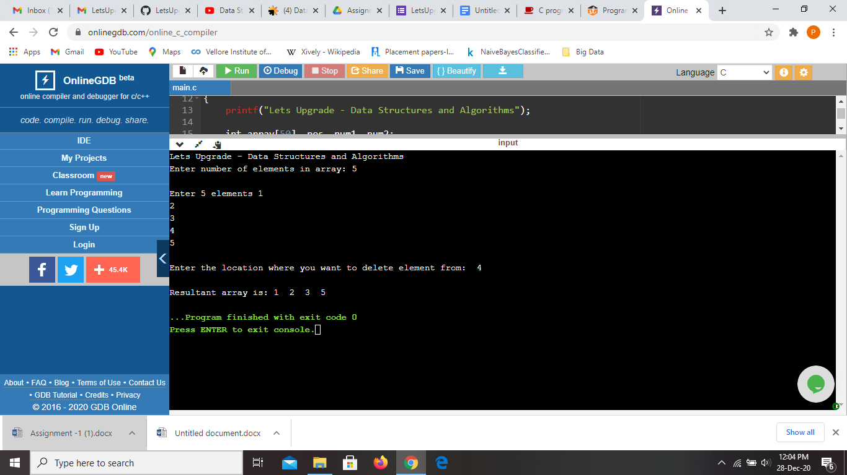

Question 2

Write the program for printing the array after rotating it k times towards left, where k

would be taken as user input.

Ans:

#include <stdio.h>

int main()

{

printf("Lets Upgrade - Data Structures And Algorithms \n");

//Initialize array

int arr[] = {1, 2, 3, 4, 5};

//Calculate length of array arr

int length = sizeof(arr)/sizeof(arr[0]);

//n determine the number of times an array should be rotated

int num;

printf("Enter the number you want to rotate from : ");

scanf("%d\n", &num);

printf("Rotating the array from left from %d number\n", num);

//Displays original array

printf("Original array: \n");

for (int i = 0; i < length; i++) {

printf("%d ", arr[i]);

}

//Rotate the given array by n times toward left

for(int i = 0; i < num; i++){

int j, first;

//Stores the first element of the array

first = arr[0];

for(j = 0; j < length-1; j++){

//Shift element of array by one

arr[j] = arr[j+1];

}

//First element of array will be added to the end

arr[j] = first;

}

printf("\n");

//Displays resulting array after rotation

printf("Array after left rotation: \n");

for(int i = 0; i < length; i++){

printf("%d ", arr[i]);

}

return 0;

}

